# **ASSIGNMENT 1**

# **BOOKS AND BYTES**

Name : Kavipriya V

Roll no: 20AD025

**1.Creating database for books and bytes:**

CREATE DATABASE BOOKSDB;

USE BOOKSDB;

CREATE TABLE BOOKS(

BOOKNO INT PRIMARY KEY,

TITLE VARCHAR(50),

AUTHOR VARCHAR(75),

PUBLICATION_YEAR INT,

PRICE INT

);

INSERT INTO BOOKS VALUES(101,"SQL FOR BEGINNERS","SHANE BLACK",2003,2800);

INSERT INTO BOOKS VALUES(102,"SQL COOKBOOK","ANTHONY MOLINORA",2005,199);

INSERT INTO BOOKS VALUES(103," LEARNING SQL","ALAN BEALIEU",2006,1500);

INSERT INTO BOOKS VALUES(104,"HANDS ON SQL","ABISHEK CHOUDARY",2011,322);

INSERT INTO BOOKS VALUES(105,"SQL PROGRAMMING","BEN CHAN",2016,384);

INSERT INTO BOOKS VALUES(106,"SQL PRACTICE PROBLEMS","SYLVIA MOESTL VASLIK",2013,2403);

**a. Retrieve all the books from the database.**

SELECT*FROM BOOKS;

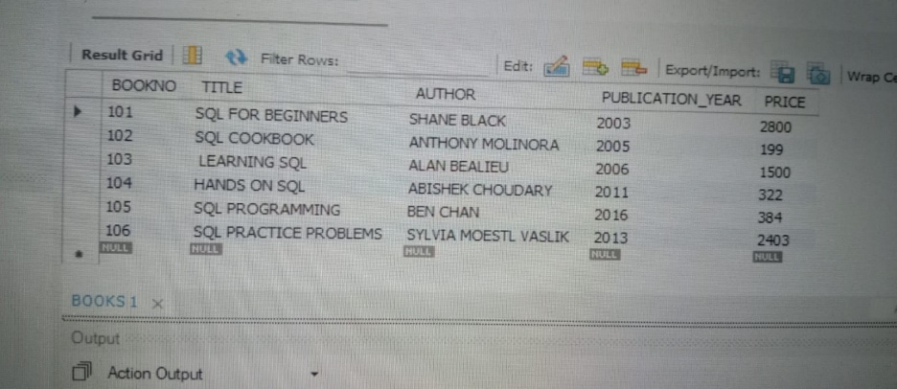

**b. Retrieve the details of a book based on its title.**

SELECT TITLE FROM BOOKS;

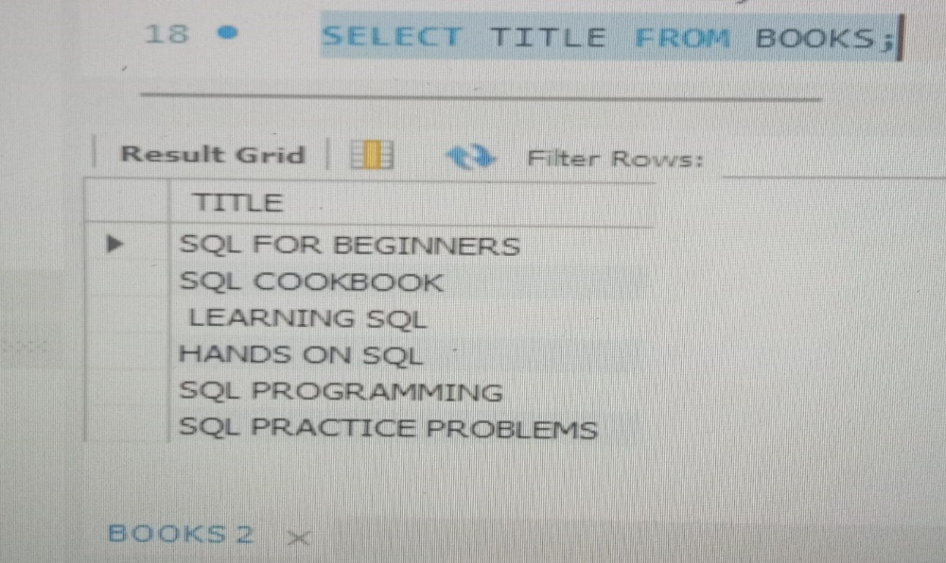

**c. Update the price of a book.**

UPDATE BOOKS SET PRICE=3000 WHERE BOOKNO=101;

UPDATE BOOKS SET PRICE=400 WHERE BOOKNO=105;

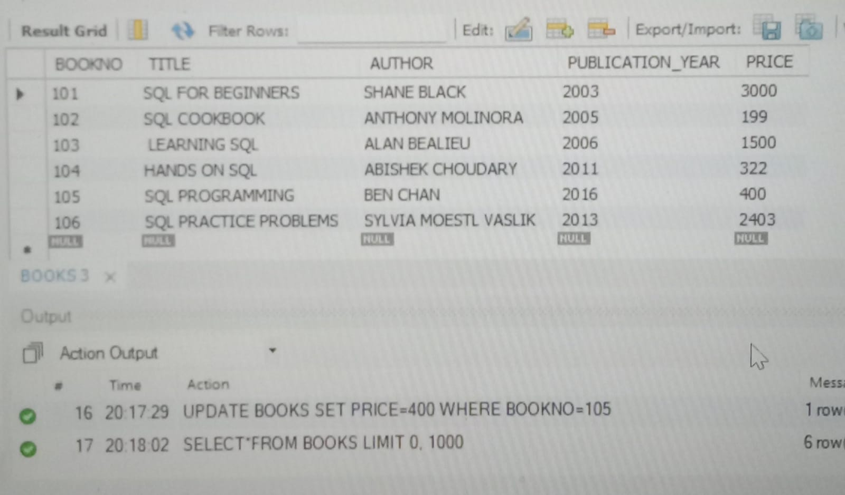

**d. Delete a book from the database based on its title**.

DELETE FROM BOOKS WHERE BOOKNO=106;

